

**MATHEMATICS DEPARTMENT**

**MATHEMATICAL METHODS YEAR 12 – TEST 3**

DATE: 27th June 2016 Name: _________________________

**CALCULATOR FREE**

**Reading Time:** 3 minutes

**Working Time:** 50 minutes

EQUIPMENT: pens, pencils, pencil sharpener, highlighter, eraser, ruler, formula sheet (provided)

|  |  |  |
| --- | --- | --- |
| **Question** | **Marks available** | **Marks awarded** |
| 1 | 4 |  |
| 2 | 6 |  |
| 3 | 6 |  |
| 4 | 3 |  |
| 5 | 6 |  |
| 6 | 5 |  |
| 7 | 6 |  |
| 8 | 7 |  |
| 9 | 9 |  |
| **Total** | **52** |  |

**Question 1 (4 marks)**

Evaluate the following:

(a)  (1 mark)

(b)  (1 marks)

(c)  (2 marks)

**Question 2 (6 marks)**

Match each of the following graphs with their equations from the given list.

A graph may have more than one matching equation. Not all equations have a matching graph.

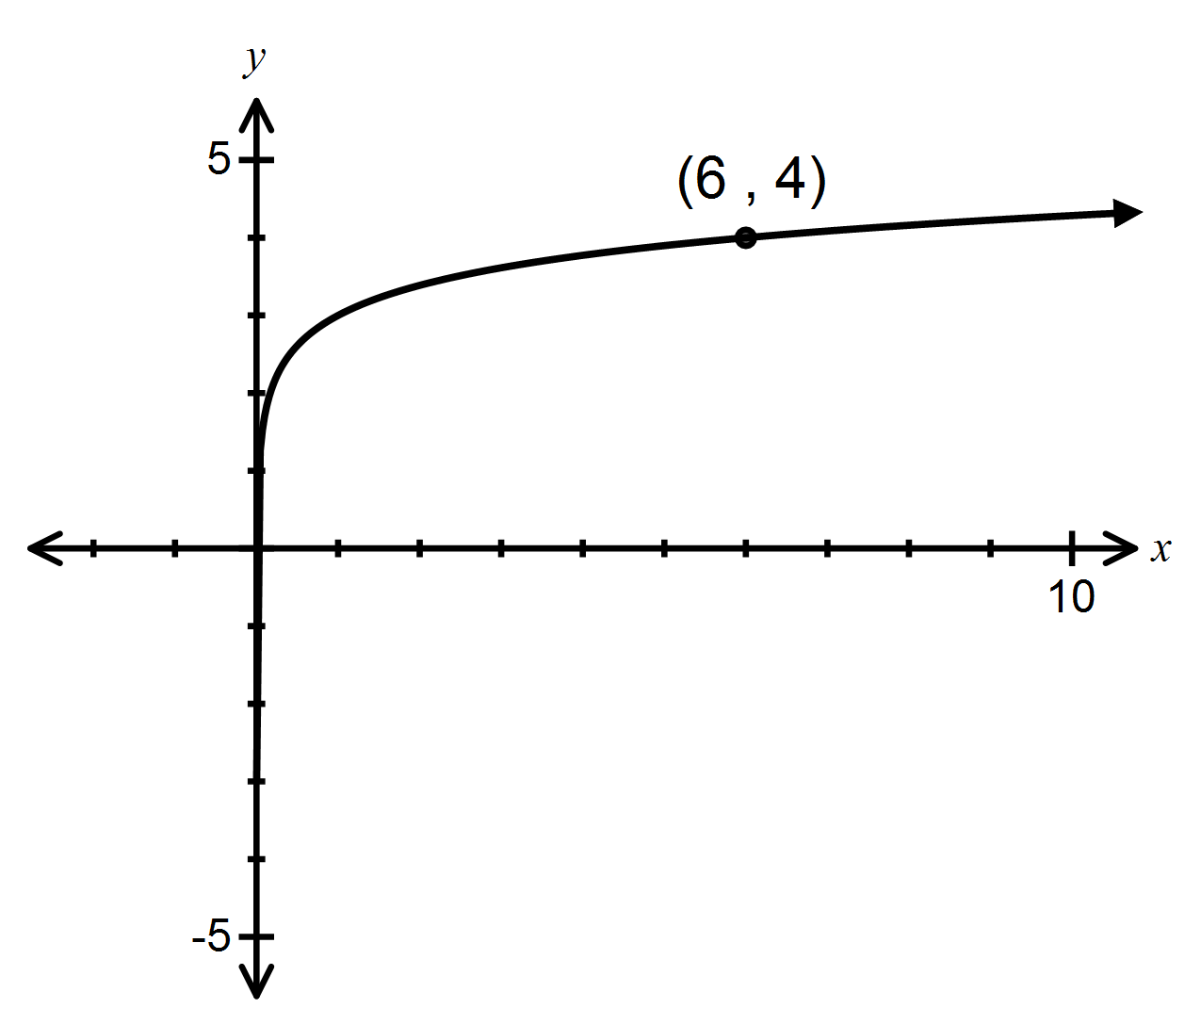 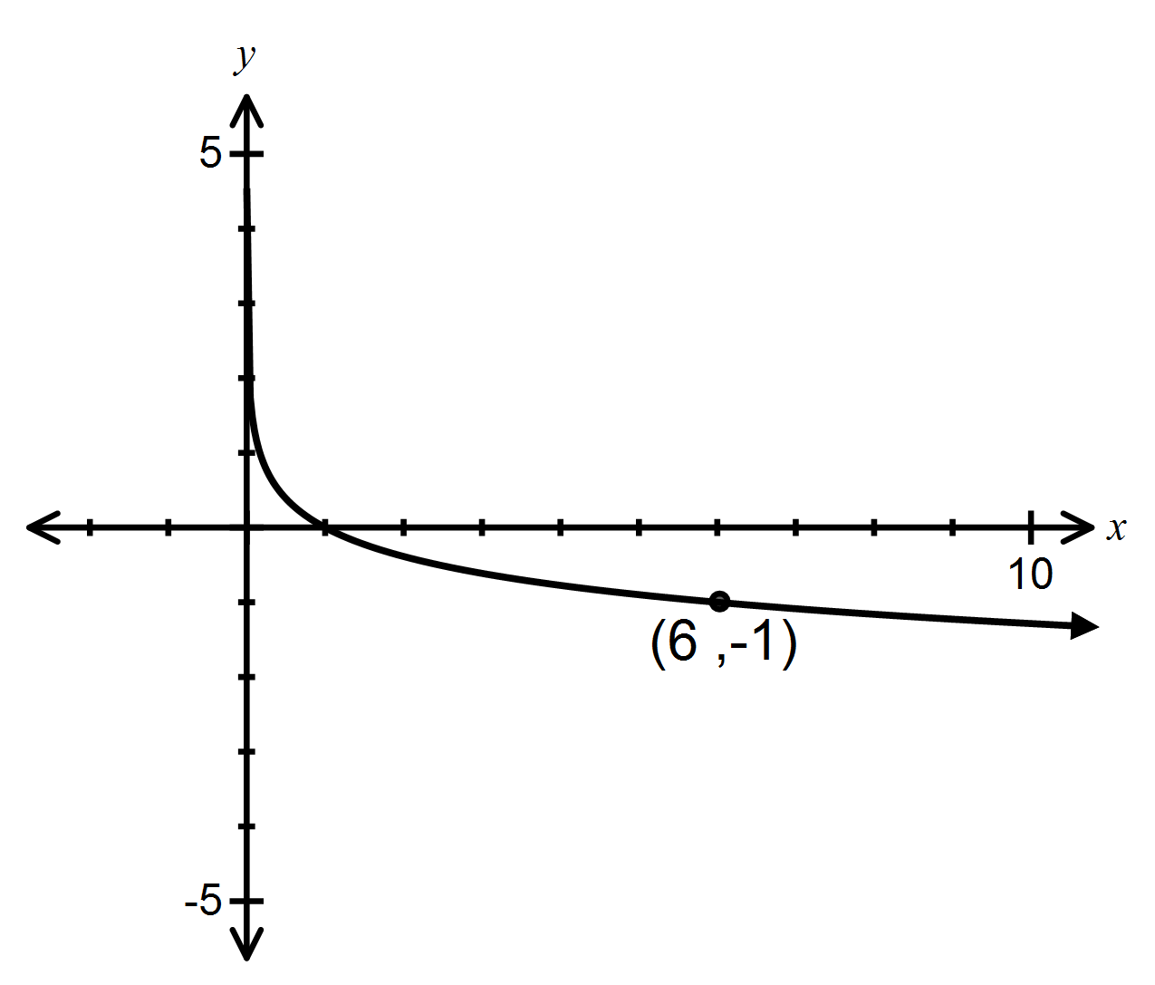

________________________ ________________________

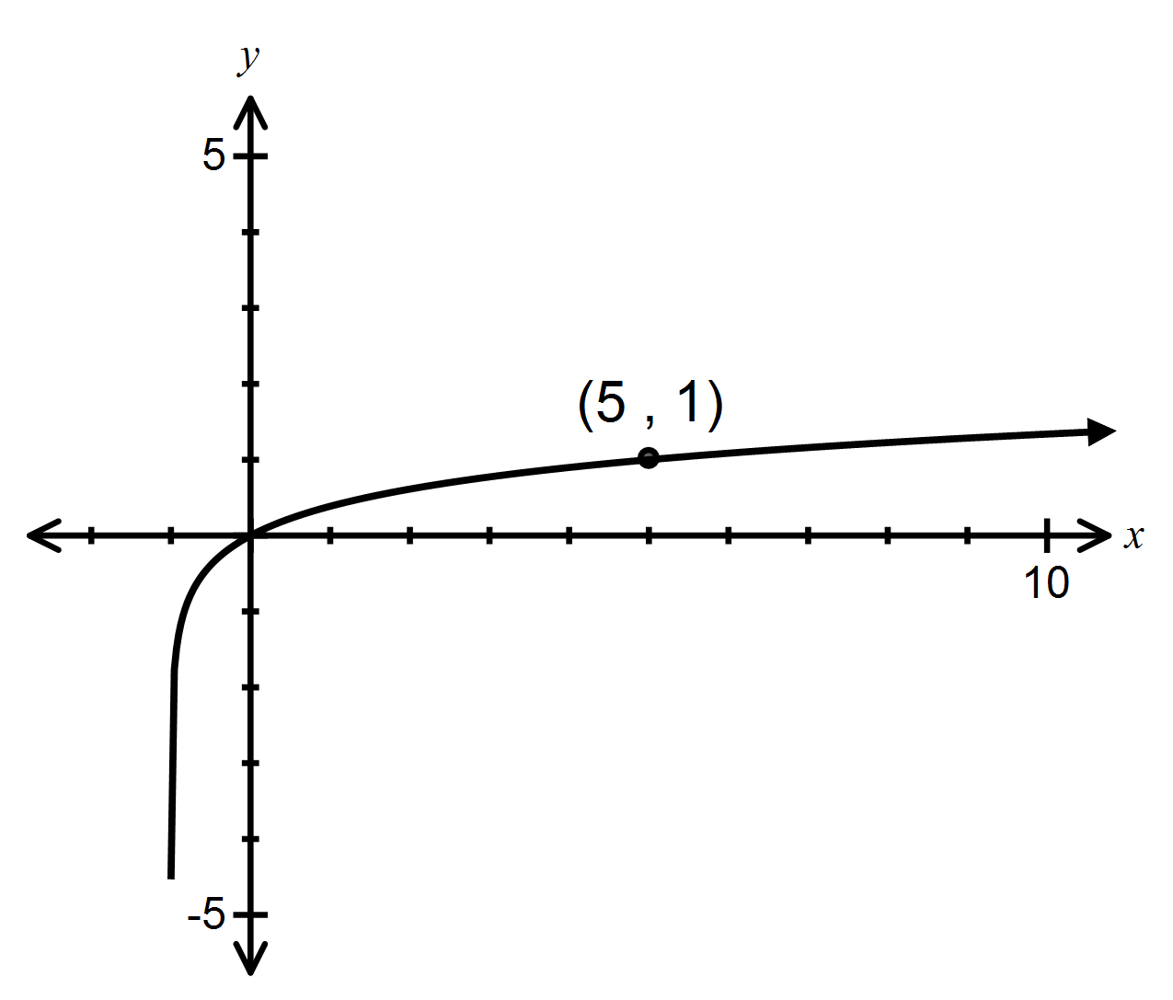 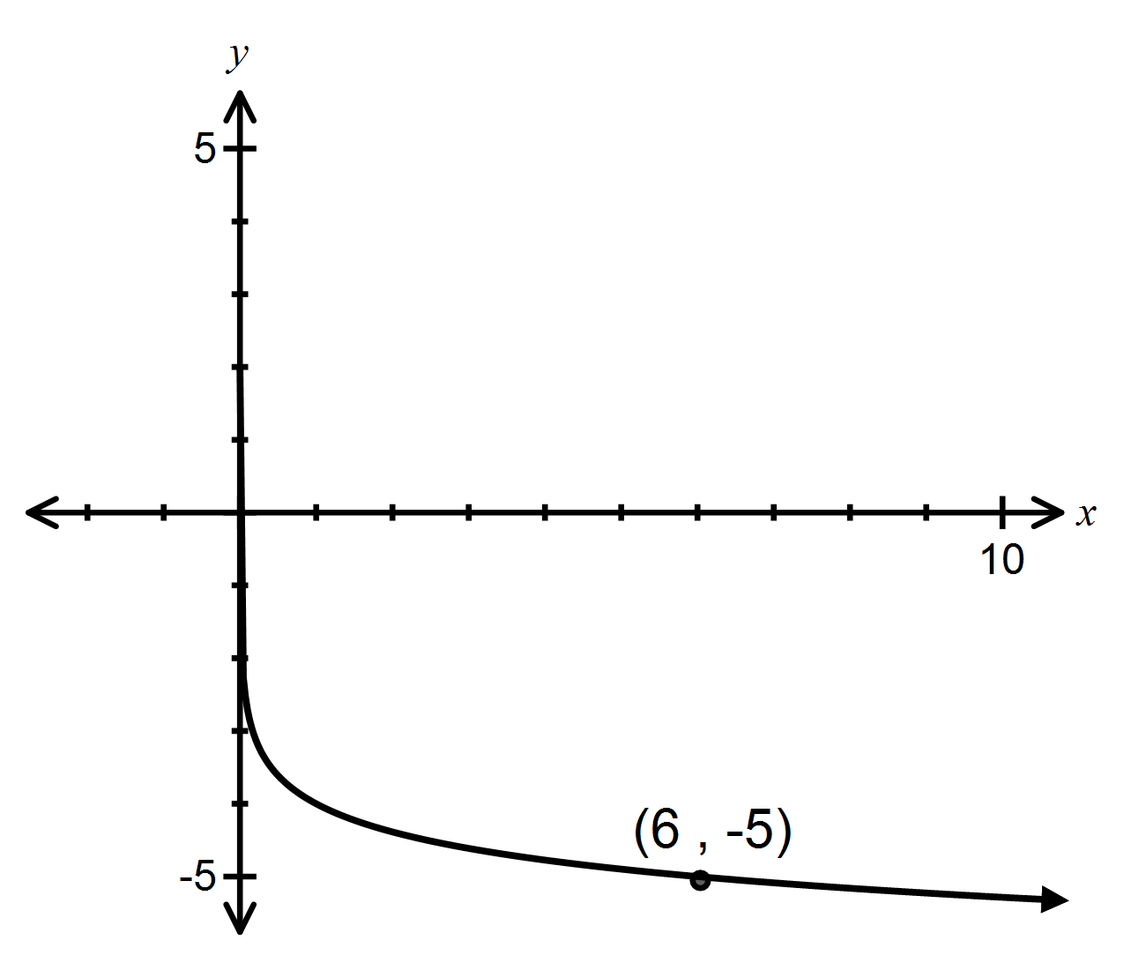

________________________ ________________________

A  B  C 

D  E  F 

G  H  I 

**Question 3 (6 marks)**

Differentiate with respect to *x.*

(a)  (1 mark)

(b)  (2 marks)

(c)  (3 marks)

**Question 4 (3 marks)**

Find the following indefinite integrals.

Assume denominators are greater than zero.

(a)  (1 mark)

(b)  (2 marks)

**Question 5 (6 marks)**

Find the exact value of *x* satisfying the equation

 .

Give your answer in the form  .

**Question 6 (5 marks)**

(a) The function *f* is defined for *x > 2* by *f(x) =* ln *x +* ln(*x –* 2) *–* ln(*x2 –* 4)*.*

Express *f(x)* in the form ln. (2 marks)

(b) Evaluate  (3 marks)

**Question 7 (6 marks)**

The shaded area is 0.2 units2.

Find *k* exactly.

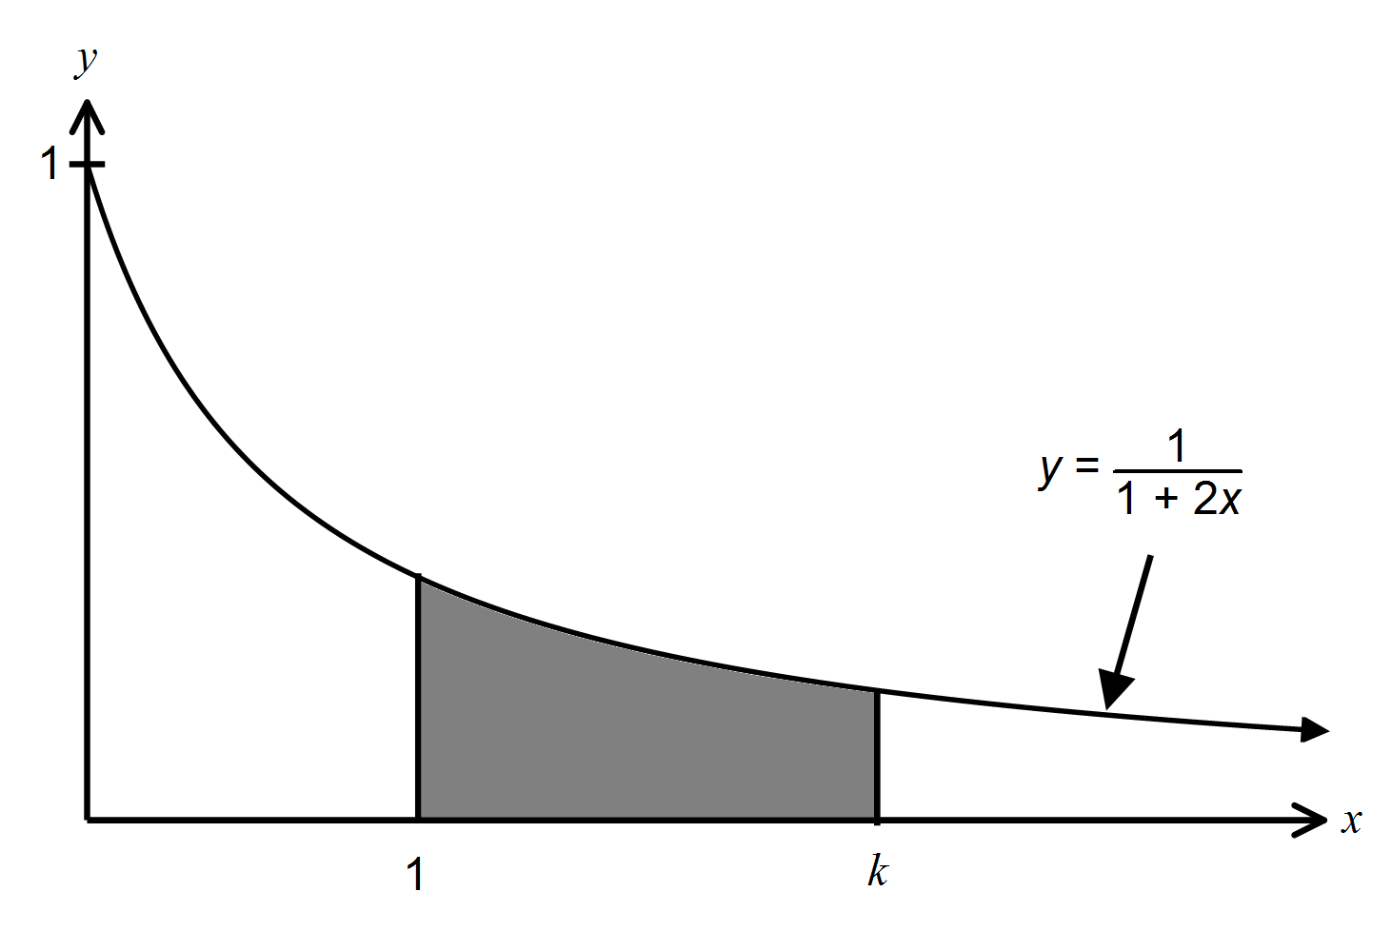

**Question 8 (7 marks)**

As part of a local arts festival, an artist plans to create an installation in which a concealed water cannon blasts a stream of water into the air for a few seconds at random intervals.

The lengths of the intervals between each firing of the cannon can be modelled by the uniformly distributed random variable , where minutes.

(a) Sketch the probability density function  for the interval between each firing on the axes below.

(2 marks)

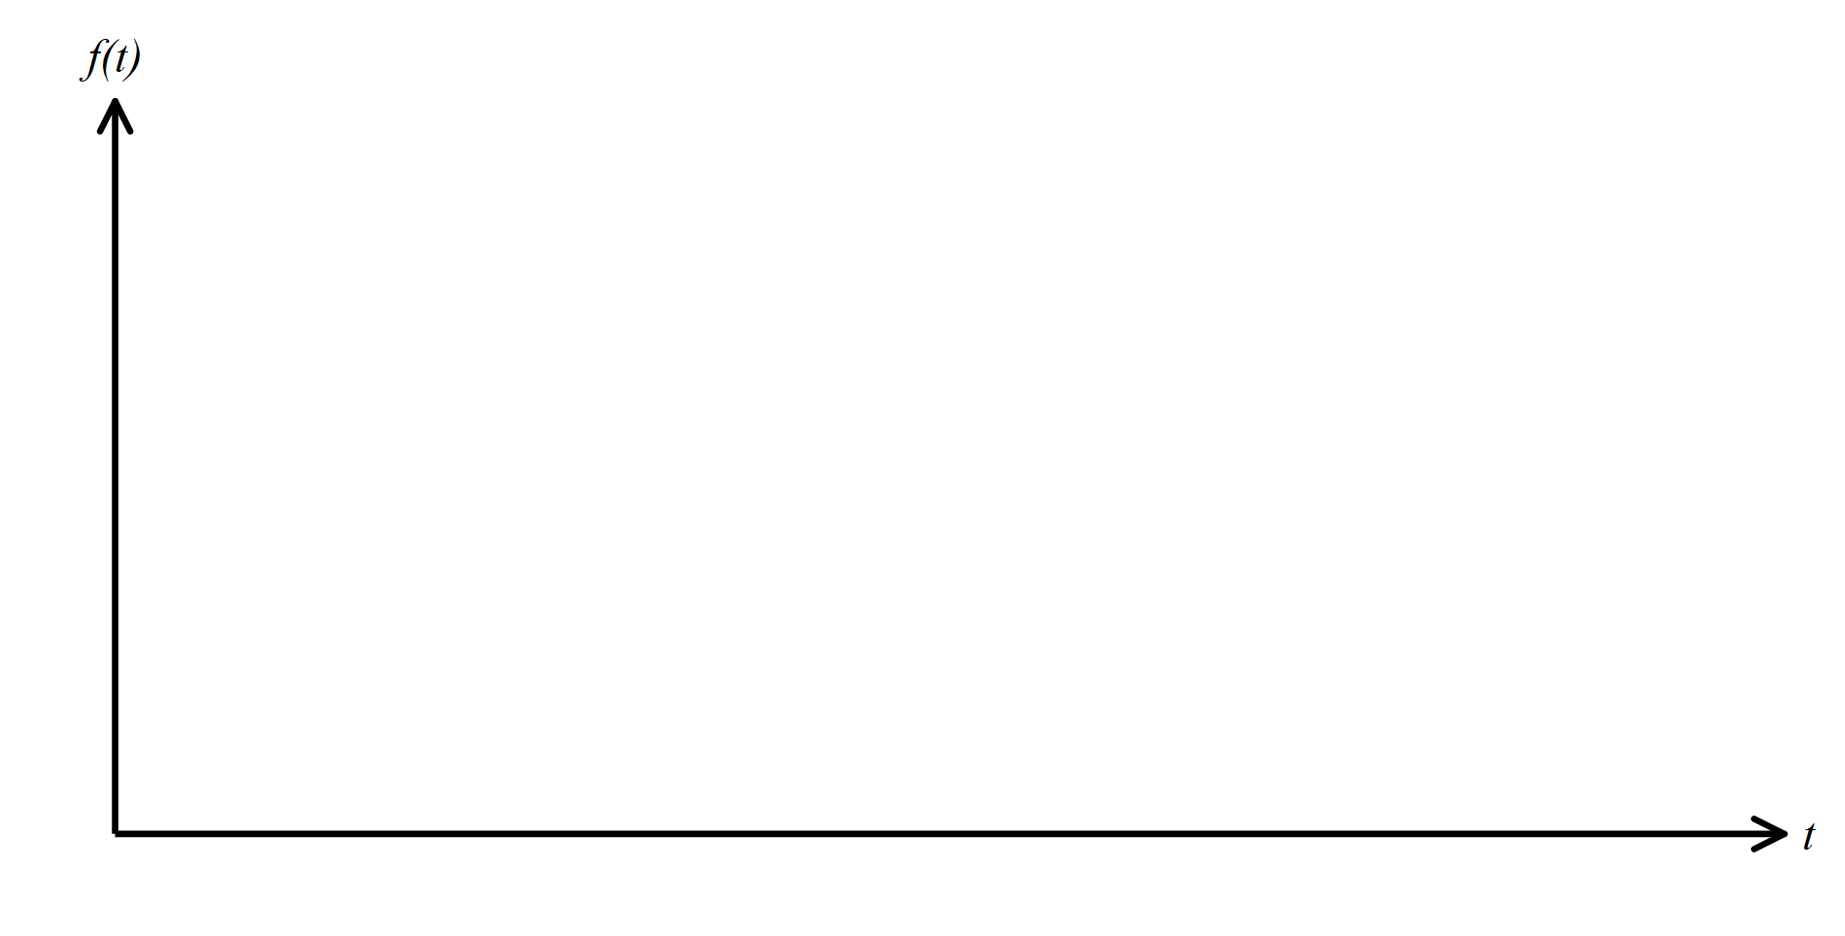

(b) Determine the probability that a randomly chosen interval between firings is

(i) at least seven minutes. (1 mark)

(ii) at least six minutes given that it is less than ten minutes. (2 marks)

(c) Determine the value of  for which  (2 marks)

**Question 9 (9 marks)**

The continuous random variable *X* is define by the probability density function

 

(a) Determine . (2 marks)

(b) The Variance of ,  , is .

(i) Determine  (1 mark)

(ii) Determine  (1 mark)

**Question 9 continued (9 marks)**

(c) Determine the cumulative distribution function  (3 marks)

(d) Calculate  (2 marks)

**End of Test**

**Additional page for working.**